Pupil premium strategy statement – St Mark’s CE Primary School

This statement details our school’s use of pupil premium (and recovery premium) funding to help improve the attainment of our disadvantaged pupils.
It outlines our pupil premium strategy, how we intend to spend the funding in this academic year and the outcomes for disadvantaged pupils last academic year.

School overview
Detail | Data
Number of pupils in school | 166
Proportion (%) of pupil premium eligible pupils | 7%
Academic year/years that our current pupil premium strategy plan covers (3 year plans are recommended) | 2023/4  2024/5  2025/6
Date this statement was published | November 2023
Date on which it will be reviewed | November 2024
Statement authorised by
Pupil premium lead | L Hinton
Governor / Trustee lead | Tim Ward

Funding overview
Detail | Amount
Pupil premium funding allocation this academic year | £17,460
Recovery premium funding allocation this academic year | £2,000
Pupil premium (and recovery premium*) funding carried forward from previous years (enter £0 if not applicable)  *Recovery premium received in academic year 2021 to 2022 can be carried forward to academic year 2022 to 2023. Recovery premium received in academic year 2022 to 2023 cannot be carried forward to 2023 to 2024. | £14,727
Total budget for this academic year  If your school is an academy in a trust that pools this funding, state the amount available to your school this academic year | £34,187

Part A: Pupil premium strategy plan

Statement of intent
When making decisions about using Pupil Premium funding it is important to consider the context of the school and the subsequent challenges faced. This alongside research conducted by the EEF.

Common barriers to learning for disadvantaged children can be: less support at home, weak language and communication skills, lack of confidence, more frequent behaviour difficulties and attendance and punctuality issues.

There may also be complex family situations that prevent children from flourishing. The challenges are varied and there is no “one size fits all”.

We will ensure that all teaching staff are involved in the analysis of data and identification of pupils, so that they are fully aware of strengths and weaknesses across the school.

Principles:
- We ensure that teaching and learning opportunities meet the needs of all the pupils
- We ensure that appropriate provision is made for pupils who belong to vulnerable groups, this includes ensuring that the needs of socially disadvantaged pupils are adequately assessed and addressed
- In making provision for socially disadvantaged pupils, we recognise that not all pupils who receive free school meals will be socially disadvantaged
- We also recognise that not all pupils who are socially disadvantaged are registered or qualify for free school meals. We reserve the right to allocate the Pupil Premium funding to support any pupil or groups of pupils the school has legitimately identified as being socially disadvantaged.
- Pupil premium funding will be allocated following a needs analysis which will identify priority classes, groups, or individuals. Limited funding and resources mean that not all children receiving free school meals will be in receipt of pupil premium interventions at one time

St Mark’s CE Primary School Context

St Mark’s School is Church of England Primary School and Nursery for pupils aged between 2 and 11 years in the village of Natland, Nr Kendal

Ultimate Objectives:

- To narrow the attainment gap between disadvantaged and non-disadvantaged pupils
- For all disadvantaged pupils in school to exceed nationally expected progress rates

Achieving These Objectives

The range of provision the Governors consider making for this group include and would not be limited to:
- To allocate a ‘Catch Up’ teacher providing small group work with an experienced teacher/HLTA focussed on overcoming gaps in learning
- 1:1 support
- Use of internal or external tutors
- Pupil premium resources are to be used to target able children on Free School Meals to achieve their potential
- Additional transition support through all key stages
- Pay for all activities, educational visits and residentials. Ensuring children have first-hand experiences to use in their learning in the classroom.
- Support the funding of resources to enhance the learning experience
- To allow the pupils to learn a musical instrument or speech and drama
- Mental health provision available to all pupils.

This list is not exhaustive and will change according to the needs and support our socially disadvantaged pupils require.

Challenges
This details the key challenges to achievement that we have identified among our disadvantaged pupils.
Challenge number | Detail of challenge
1 | Weak Language and Communication skills including a lower reading age
2 | Lower attainment and progress and a widening gap between disadvantaged and non-disadvantaged pupils
3 | Reduced exposure to cultural capital
4 | Attendance and Punctuality issues
5 | Poor mental health and wellbeing

Intended outcomes
This explains the outcomes we are aiming for by the end of our current strategy plan, and how we will measure whether they have been achieved.
Intended outcome | Success criteria
Improved writing in the Primary school | Improve writing attainment
Improved reading ability and vocabulary acquisition for all disadvantaged pupils | Improved reading ages to chronological age
Improve the current attainment and progress of disadvantaged pupils | Progress improved
Improved well-being | Fewer referrals to external agencies  A reduction in the number of pupils reporting anxiety

Activity in this academic year
This details how we intend to spend our pupil premium (and recovery premium) funding this academic year to address the challenges listed above.

Teaching (for example, CPD, recruitment and retention)
Budgeted cost: £ 5,000
Activity | Evidence that supports this approach | Challenge number(s) addressed
Curriculum development CPD | It is imperative that our curriculum is properly sequenced and therefore effective. This is a clear focus of the school’s development plan. | 1 and 2
Phonics training | As the building block of reading, and therefore the key to unlocking all learning. Our phonics scheme requires all teaching and support staff in KS1 to have regular CPD to remain current | 1 and 2
Phonics resources | Without high quality resources the scheme is less effective and impactful. | 1 and 2
Embed the use of planning and assessment grids in all foundation subjects. | This is a key part of effectively sequencing the curriculum, supporting children with knowledge acquisition. | 1 and 2
Writing CPD for Primary | Our attainment in writing is not as high as we would like. We would like to invest in CPD to support the skills of our teachers in this area. | 1 and 2

Targeted academic support (for example, tutoring, one-to-one support, structured interventions)
Budgeted cost: £ 16,000
Activity | Evidence that supports this approach | Challenge number(s) addressed
Mosaics Breakfast Club | No pupil should start the day hungry, if you are hungry, you are unlikely to be able to concentrate | 4 and 5
Mosaics After School Club | Pupils are supported to complete homework and have time to talk to staff, allowing parents to maintain jobs. | 4 and 5
Primary interventions | Individualised support is vital to reduce the attainment gap. | 1 and 2

Wider strategies (for example, related to attendance, behaviour, wellbeing)
Budgeted cost: £ 13000
Activity | Evidence that supports this approach | Challenge number(s) addressed
Music, Speech and Drama | All pupils should have the opportunity to experience learning an instrument or achieving grades in Speech and Drama. This is also used for targeted support for behaviour and attendance. | 3 and 5
Well-being resources | Pupils at St Mark’s can suffer from a lack of access to hot water, washing machines and uniform that fits. We feel that the well being of our disadvantaged pupils is in jeopardy if they are unable to access support to meet these basic needs. | 5
Mental Health first aid training | There is a need to support our pupils when in crisis | 5
Support to attend trips and events | Well being and the acquisition of cultural capital is vital for our disadvantaged pupils. Without support many pupils would not be able to take part in extra curricular trips and visits. | 3 and 5

Total budgeted cost: £ 34,000

Part B: Review of the previous academic year

Outcomes for disadvantaged pupils
Key Stage 2 SATS
Please note the FSM6 line for outcomes. These results are based on only 3 children.
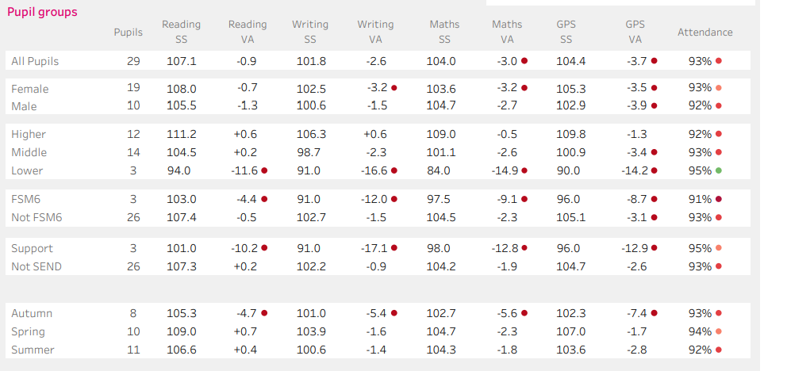
KS1 SATS
Please note the FSM6 line for outcomes. These results are based on only 1 child so not statistically relevant.
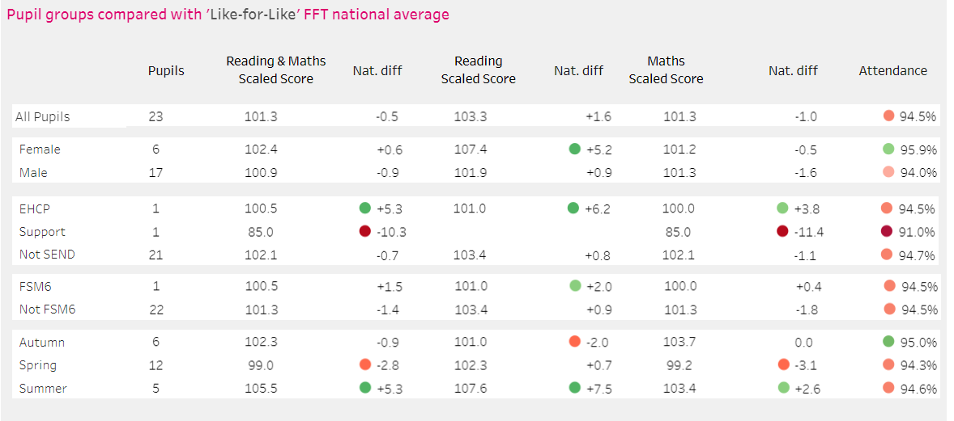

Previous Academic Year |  | 2022-23
Quality of teaching for all
Desired outcome | Chosen action / approach | Estimated impact: Did you meet the success criteria? Include impact on pupils not eligible for PP, if appropriate.
Weak Language and Communication skills including a lower reading age  And  Lower attainment and progress due to COVID-19 than before the pandemic | Curriculum development CPD | We started this journey in 21-22 and the benefits are beginning to be realised. The learning experience is more coherent which positively affects all pupils. More work is still to be done in the coming year.
Weak Language and Communication skills including a lower reading age  And  Lower attainment and progress due to COVID-19 than before the pandemic | Phonics training | New scheme introduced and up and running with key staff trained
Weak Language and Communication skills including a lower reading age  And  Lower attainment and progress due to COVID-19 than before the pandemic | Phonics resources | Pupils are engaging more effectively with phonics due to the improvement in the resources. Phonics results are improving.
Targeted support
Desired outcome | Chosen action / approach | Estimated impact: Did you meet the success criteria? Include impact on pupils not eligible for PP, if appropriate.
Attendance and Punctuality issues  And  Poor mental health and wellbeing | Breakfast Club | Breakfast clubs that offer pupils in primary schools a free and nutritious meal before school can boost their reading, writing and maths results by the equivalent of two months’ progress over the course of a year, according to the results of a randomised controlled trial published by the Education Endowment Foundation. The evaluators reported that the pupils’ concentration and behaviour improved too. At St Mark’s we have anecdotal evidence that our pupils concentration and focus improved due to attendance at a breakfast club. We intend to measure impact next year of this.
Attendance and Punctuality issues  And  Poor mental health and wellbeing | After School Club | Pupils benefitted from improved physical health through diet and exercise, Improved mental health and behaviour, better academic performance and increased social skills and confidence. The home life is supported for pupils
Lower attainment and progress due to COVID-19 than before the pandemic | Tutoring | Pupils given 1:1 tutoring in the summer term from trained teachers
Other approaches
Desired outcome | Chosen action / approach | Estimated impact: Did you meet the success criteria? Include impact on pupils not eligible for PP, if appropriate.
Attendance and Punctuality issues and  Poor mental health and wellbeing | Music lessons | Pupils accessed music lessons providing them with an accessible learning environment while also supporting their language and communication skills.
Poor mental health and wellbeing | Well-being and attendance resources | Support was provided to pupils who were struggling to wear correct uniform
Poor mental health and wellbeing | Support to attend trips and events | This support ensured that all pupils were able to access rewards and trips. Pupils gained cultural capital and were not stigmatised for being unable to afford the events. These included residentials and trips to the Theatre, Tullie House, Young Voices, Liverpool and Leighton Moss.
Weak Language and Communication skills including a lower reading age and  Lower attainment and progress due to COVID-19 than before the pandemic | Additional support in classrooms | The use of additional support in classrooms was effective. Pupil were able to access 1:1 support in the moment and misconceptions clarified. Where this support was regular and pupils' attendance was good, a clear impact was seen.

