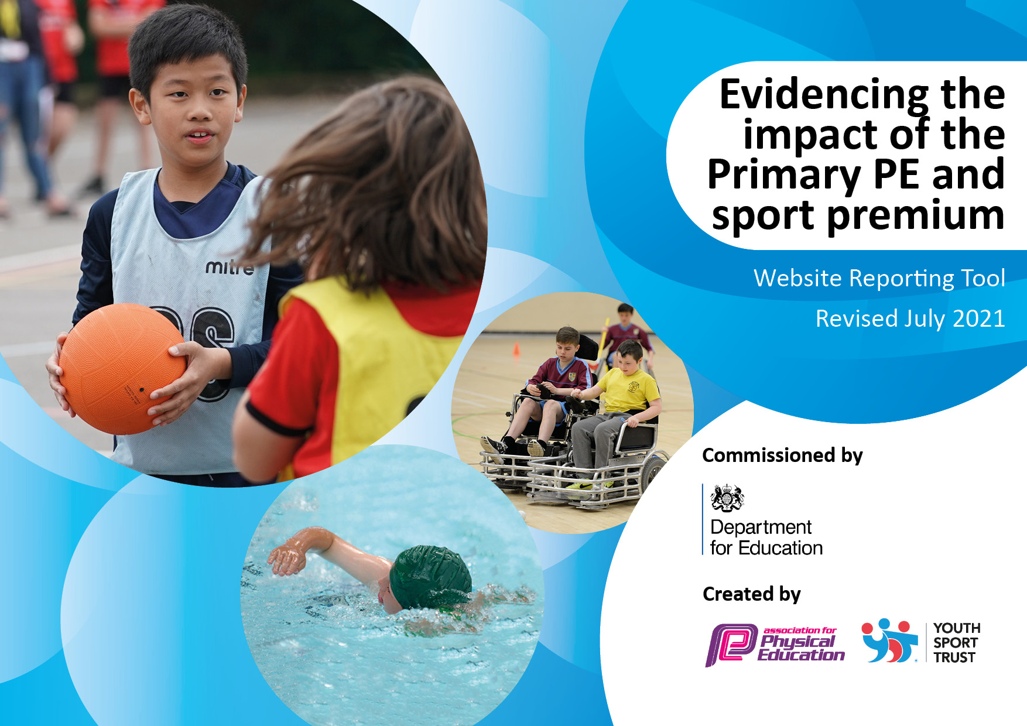
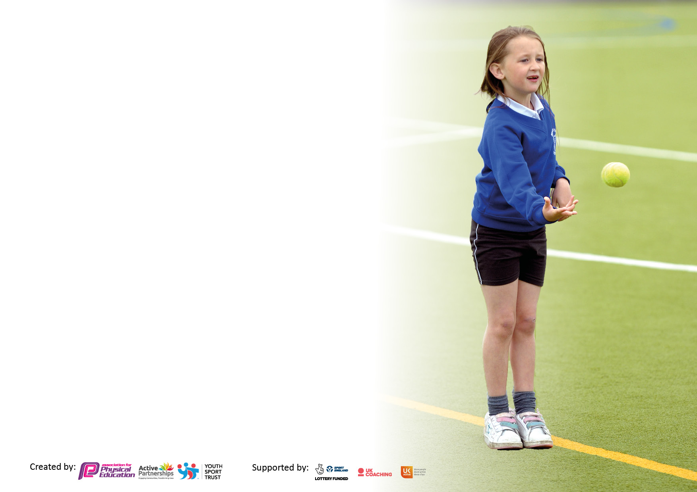

It is important that your grant is used effectively and based on school need. The Education Inspection Framework makes clear there will be a focus on ‘whether leaders and those responsible for governors all understand their respective roles and perform these in a way that enhances the effectiveness of the school’.

Under the Quality of Education Ofsted inspectors consider:
Intent - Curriculum design, coverage and appropriateness
Implementation - Curriculum delivery, Teaching (pedagogy) and Assessment
Impact - Attainment and progress

To assist schools with common transferable language this template has been developed to utilise the same three headings which should make your plans easily transferable between working documents.

Schools must use the funding to make additional and sustainable improvements to the quality of Physical Education, School Sport and Physical Activity (PESSPA) they offer. This means that you should use the Primary PE and sport premium to:

- Develop or add to the PESSPA activities that your school already offer
- Build capacity and capability within the school to ensure that improvements made now will benefit pupils joining the school in future years
- The Primary PE and sport premium should not be used to fund capital spend projects; the school’s budget should fund these.

Pleasevisitgov.ukfortherevisedDfEguidanceincludingthe5keyindicatorsacrosswhichschoolsshoulddemonstrate animprovement.Thisdocumentwillhelpyoutoreviewyourprovisionandtoreportyourspend.DfEencouragesschools to use this template as an effective way of meeting the reporting requirements of the Primary PE and sport premium.

We recommend you start by reflecting on the impact of current provision and reviewing the previous spend.

Schools are required to publish details of how they spend this funding, including any under-spend from 2019/2020, as well as on the impact it has on pupils’ PE and sport participation and attainment. All funding must be spent by 31st July 2022.

We recommend regularly updating the table and publishing it on your website throughout the year. This evidences your ongoing self-evaluation of how you are using the funding to secure maximum, sustainable impact. Final copy must be posted on your website by the end of the academic year and no later than the 31st July 2021. To see an example of how to complete the table please click HERE.
Created by: Supported by:

Swimming Data
Please report on your Swimming Data below.

Meeting national curriculum requirements for swimming and water safety.  N.B. Complete this section to your best ability. For example, you might have practised safe self-rescue techniques on dry land which you can then transfer to the pool when school swimming restarts.  Due to exceptional circumstances priority should be given to ensuring that pupils can perform safe self-rescue even if they do not fully meet the first two requirements of the NC programme of study | Children attended a 6-week block of swimming lessons at Kendal Leisure Centre in year 4 and year 5. Children who had not yet met the national curriculum requirement had an extra block of lessons.  Children completed an open water safety day in year 5.
What percentage of your current Year 6 cohort swim competently, confidently and proficiently over a distance of at least 25 metres?  N.B. Even though your pupils may swim in another year please report on their attainment on leaving primary school at the end of the summer term 2021.  Please see note above | 80%
What percentage of your current Year 6 cohort use a range of strokes effectively [for example, front crawl, backstroke and breaststroke]?  Please see note above | 74%
What percentage of your current Year 6 cohort perform safe self-rescue in different water-based situations? | 90%
Schools can choose to use the Primary PE and sport premium to provide additional provision for swimming but this must be for activity over and above the national curriculum requirements. Have you used it in this way? | Children attended an outdoor opening water swimming safety session in year 5.

Action Plan and Budget Tracking
Capture your intended annual spend against the 5 key indicators. Clarify the success criteria and evidence of impact that you intend to measure to evaluate for pupils today and for the future.

Academic Year: 2022/23 | Total fund allocated: | Date Updated:
Key indicator 1: The engagement of all pupils in regular physical activity – Chief Medical Officers guidelines recommend that primary school pupils undertake at least 30 minutes of physical activity a day in school |  |  |  | Percentage of total allocation:
 |  |  |  | 23%
Intent | Implementation |  | Impact | Sustainability and suggested next steps:
We want every child in school to have the opportunity to have regular daily exercise. This includes opportunities to run at length at playtimes as well as having regular breaks during lessons for running. | Each class ensures they complete the daily mile.  Children to do the Wake and Shake on wet days to increase physical activity  Reception to use Imoves to ensure they are physically active within the classroom. | IMoves Reception subscription £50  Walsall wake and shake £0 | Evidence of impact: The children regularly do the daily mile throughout the day. We have used it for general fitness and have begun to enter cross country events, with some children doing very well. | Continue to include daily breaks for physical activity.  Encourage active and outdoor learning.  To introduce a competitive element to the daily mile. Children to try and beat their PB.
Installation of new outdoor climbing equipment on the top section of the field to encourage the older children to improve their balance strength and agility. | Equipment installed on the top section of the field. Children to bring in outdoor shoes to make more use of the field in all weather. | £2,469 | Children are regularly using both pieces of equipment. This will improve their upper body strength. | Support and train he younger children to use equipment safely
Key indicator 2: The profile of PESSPA being raised across the school as a tool for whole school improvement |  |  |  | Percentage of total allocation:
 |  |  |  | 1%
Intent | Implementation |  | Impact | Sustainability and suggested next steps:
Additional equipment bought to improve sports days provision. | Equipment purchased to ensure sports day runs quickly and smoothly.  Egg and Spoons purchased. | £8.31 | Enhancing PE opportunities | Equipment Audit to be carried out. Ensure new equipment purchased is stored correctly and is looked after.

Key indicator 3: Increased confidence, knowledge and skills of all staff in teaching PE and sport |  |  |  | Percentage of total allocation:
 |  |  |  | 46%
Intent | Implementation |  | Impact | Sustainability and suggested
To ensure good quality teaching across a range of sports. Ensure all teachers get CPD opportunities by using outside specialist coaches to develop teacher’s confidence and ensure we teach a range of activities. | A range of specialist teachers have worked with children in school. Teachers have used the opportunity as CPD throughout the year.  Tennis coach for years 4 and year 6.  Matt Harris worked with every year group working on fundamental movement skills, lacrosse, cricket and basketball. | £5,120 | Teachers have used new ideas and feel more confident in sports they have previously not taught such as lacrosse.  It has been beneficial for children to engage with a variety of coaches with different teaching styles and specialisms.  Feedback from experienced teachers was positive. | To continue while funding is available.  Next steps: Seek out other CPD opportunities such as dance and gymnastics.
Key indicator 4: Broader experience of a range of sports and activities offered to all pupils |  |  |  | Percentage of total allocation:
 |  |  |  | 3%
Intent | Implementation |  | Impact | Sustainability and suggested next steps:
Increase the range of after school and lunchtime clubs offered. | Afterschool clubs offered:  Fit Kids Club  Football and Dodge ball  Cross country club  Rounders | Parents pay for Fit Kids Club and Football and Dodgeball club as they are fun by outside providers.  No cost for Cross country club and rounders as QD runs these. | Children are offered a greater variety of clubs in an environment they feel comfortable and safe. Subject leader feels more confident to lead and run a wider range of clubs since working with specialist sports coaches in sports such as basketball, tennis, cricket and lacrosse. | Subject lead to run a wider range of sports clubs. This is sustainable even if the funding is reduced or stopped.
Reception children to learn to ride, or learn how to ride more safely, a bike within school | Pedal and Scoot to run bike ability sessions within school. | £440 | Children’s confidence increased and progress was made. Children felt confident to have a go whilst being surrounded by friends in a familiar and safe environment. | To continue whilst funding allows.

Key indicator 5: Increased participation in competitive sport |  |  |  | Percentage of total allocation:
 |  |  |  | 27%
Intent | Implementation |  | Impact | Sustainability and suggested next steps
To continue to give our children as many opportunities as possible to take part in external competitions  To ensure inclusivity when sending children to sporting events.  The children took part in cross country this year and were fairly successful due to their increased running stamina. | Children took part in a wide range of sporting activities such as ten pin bowling, cross country, kwick cricket, netball, rounders, football, dodgeball, athletics and Tri -golf.  To ensure equal opportunities for all children to attend sporting events. The focus from the school games offer this year was on ensuring children with SEND get equal opportunities to attend sporting events. | £67.00 | With the School Games focus on inclusivity. It has meant many more children have experienced competitive events now the criteria for which children you put forward has changed. This has had a positive impact on children’s self confidence and resilience when attending events.  The offer of activities supporting SEND within competitive sports have been good this year and we attended many with the St Mark’s team of 6 children qualifying for the national finals in Ten Pin Bowling. | Next steps: To ensure KS1 get to attend some sporting events.
Sport leader to organise the competitive events to ensure we do not miss out on any opportunities. | Sport leader to be given time each day to respond to emails, liaise with staff and ensure the smooth running of the out of school sporting events, | £2,997.00 | This raises the profile of the school if we attend – and are successful at – as many events as possible. We had 4 children qualify for the national cross country event after being placed highly in the first round. The St Mark’s team came 3rd overall in athletics.0 | Stay up to date of the competition calendar through our Local Games |Officer, Sharon Nicholson.

Signed off by
Head Teacher: | Louise Hinton
Date: | 28/9/23
Subject Leader: | Quita Davies
Date: | 28/9/23
Governor:
Date:

